ECE 4972/4973: Final Report

Cell Imaging 2026
  - MATLAB Cell Deformation Analysis

John Ahn, Jonathan Kim, and Demetrius Schank


Abstract
This should be a concise, single paragraph that summarizes the whole report. It should be about 100-200 words total and highlight only the key aspects of the report.

Contents
Abstract 2
Chapter 1: Introduction 5
Point-Of-View Statement 5
Problem Statement 5
Ethnographic Research 6
Brainstorming 8
Three Best Ideas 10
Chapter 2: Initial Design 13
Constraints and Criteria 13
Decision Matrix 13
Decision 14
Solution Description 14
Chapter 3: Project Technical Details 16
Project Overview 16
Specifications 16
Testing Summary 16
Testing Plan 17
Schematics and Drawings 27
Client Materials 27
Chapter 4: Broader Impacts 28
Public Health, Safety, and Welfare 28
Global, Cultural, and Social 28
Environmental 29
Economic 29
Engineering Standards 29
Risk Assessment 30
Chapter 5: Project Management 31
Schedule 31
Personnel 33
Parts and Components 34
Skills and Tools 34
Budget 35
Chapter 6: Achievements and Conclusions 36
Achievements 36
Conclusions 36
References 37
Appendix A: Ethnographic Research 39
Appendix B: Code/Schematics/Etc. 40

Chapter 1: Introduction
In this chapter, the foundational context, research process, and design evolution of the cell imaging project will be explored. The need for an accessible, accurate, and affordable cell imaging solution will be introduced through the project’s point-of-view and problem statements. Ethnographic research will be discussed through insights gained from interviews with prior teams, graduate and undergraduate students, and expert faculty members all from Villanova. Additionally, the technical challenges in existing imaging workflows will be presented.
A review of current literature will be examined to provide a broader technical framework, highlighting existing methodologies and tools in cell imaging, machine learning, and microscopy. The brainstorming process that led to the selection of a final approach will be outlined, and key design ideas will be presented and evaluated.

Point-Of-View Statement
Dr. Wynne and other cell image analysis researchers need an efficient and accessible method to detect cell deformation over time from microscopy images and videos because existing solutions either require expensive specialized systems or rely on time-intensive manual analysis.

Problem Statement
Current methods for live cell imaging are required to use expensive technology; thus, a more affordable option is being sought by Dr. Wynne. Cell imaging is enabled to allow researchers to analyze characteristics of cells through capillaries. At present, the most effective way to define cell boundaries for analysis without expensive technology is considered to be manual segmentation. This process, as explained by Dr. Wynne, is considered very time-consuming and inefficient. Therefore, it has been requested that a method be found using MathWorks® MATLAB to digitally detect cell boundaries moving through capillaries with accuracy and precision. Existing methods for cell counting on MATLAB have been noted, so a breakthrough is being sought to push the boundaries of widely available methods for those without access to expensive technology. Included among current methods are, but are not limited to: CellSegm [7], the MATLAB Instruction Tool (MIC) [5], and Pedro’s segmentation [14]. In addition, a working system in MATLAB for cell edge detection using (microscopy) images has been developed by the Cell Imaging 2025 Capstone team. The specific characteristics that the project should observe are left up to the project member’s discretion. In the Cell Imaging 2025 Project, a focus was placed on cell speed and velocity of cells through capillaries. In the Cell Imaging 2026 Project, a focus is placed on cell deformation through capillaries. Moreover, the application of machine learning to this project has been proposed by Dr. Wynne, by which features such as cell categorization may be enabled. Therefore, the scope of the project has been structured to evolve depending on its progress: (a) In MATLAB, cell deformation is to be measured between microscopy frames from pre-recorded cell imaging videos, (b) Cell deformation at any given time is to be detected from microscopy images (frames) from pre-recorded cell imaging videos or live microscopy videos, and (c) Imaged cells are to be categorized, with or without the application of machine learning. The capturing of cell images or videos, or the advancement of technology required to do so, is not being undertaken by this project. Based on current research, fluorescence microscopy technologies are considered too advanced for the team and are known to require extensive expertise in microbiology, image acquisition, and hardware manufacturing. In summary, an accurate, accessible solution to cell imaging is being sought to support basic research in cell technologies without dependence on high-tech imaging systems.
Possible users of this type of cell imaging technology are identified as professors, graduate students, medical professionals, pharmaceutical professionals, and researchers. Stakeholders for this technology are identified as hospitals and research institutions. Once again, the baseline objective has been defined as the analysis of cell images and the accurate measurement of cell deformation between two frames, or moments, in time. The development of new imaging technologies is not being pursued; rather, advancements in the functionality of existing technology are being targeted. Identification of specific cell culture lines is not the aim; instead, an efficient, low-cost, effective, and available method of defining cells and their boundaries in images and recorded videos is being sought.

Ethnographic Research
Interview Insights
Several recurring themes were identified through interviews with the 2025 Cell Imaging group and graduate student, Jay. First, it was evident that data access and project scope were encountered as early obstacles. A pivot from shape detection in static images to cell velocity measurements in imaging videos (of polystyrene microspheres) was made by the previous team due to a lack of labeled image data and lab access. As a result, the project’s trajectory and overall work methodology were adjusted. MATLAB was used as the primary tool throughout, as some research and preexisting code from earlier versions of the project had been passed down by previous groups. However, unstructured, uncommented code and outdated toolboxes were encountered as challenges. The importance of clarifying and defining the types of cells to be studied (e.g., 3T3 mammalian cells vs. polystyrene cells) was emphasized by the group to avoid incompatible data and redundant work. The importance of subgoals and user interface development was also emphasized by the 2025 group.
Similar points were presented by Jay Fu, based on his own lab experience. It was explained that cell imaging at the microfluidic level is often performed by tracking small particles through narrow channels while background noise is reduced and detection rates are improved. Real-world experiments with hollow-core optical fibers and microfluidic pumps were included in his work. Videos captured by Jay were provided to the 2025 group, which led them to their revised project direction. Research resources on the microscopic level were also shared by him, and journals such as Lab on a Chip and PNAS were recommended.
The intersection of cell biology, imaging technology, and machine computation tools in healthcare was explored through interviews with Jasmine Soriano and Dr. Meltem Izzetoglu. The importance of understanding cell types such as ameloblasts and odontoblasts in dental diagnostics and treatment was discussed by Jasmine. Cell segmentation and counting were linked by her to practical applications, including oral cancers and monitoring of oral tissue health. Although only limited experience with cell segmentation was held by her, its growing relevance to dental research and practice was acknowledged. A technical outlook on machine learning in medical imaging was provided by Dr. Izzetoglu. Challenges such as data availability were highlighted, and a focus on traditional machine learning over deep learning was advised by her if the project were to proceed in that direction. Simulation-based methods, including Monte Carlo modeling to generate synthetic data, were recommended by her for training purposes. It was concluded that machine learning was constrained due to the limited dataset, and the project was not pursued in that direction.

Observation Insights
Technical challenges that undermine the reliability and reproducibility of cell imaging were revealed through observational analysis (an analysis of fluorescent imaging techniques from a Cell Signaling Technology, Inc. video). Inconsistent imaging across software platforms, low reproducibility rates of experiments, misleading image contrast due to differing staining methods, and cost barriers were identified as some of these challenges. The importance of selecting datasets that reflect consistent imaging protocols and meaningful biological staining was reinforced by all these issues.

Literature Review Insights
Several reviewed studies were found to be directly aligned with issues that had been encountered during interviews and observations, and other studies introduced new methodologies that could be used to guide future implementation. For example, ultraprecision micromachined microfluidic channels for flow cytometric analysis were described by Kummrow et al., and enhanced detection sensitivity along with reduced sample volume were achieved through their use—findings which were aligned with the project’s goals of cost-effective and efficient imaging [1]. Hydrodynamic focusing was also featured in this approach, and it was ensured that cells flowed in single file for more precise imaging.
A comparison of flow imaging microscopy (FIM) instruments such as FlowCam and MFI was conducted in another article, and their ability to detect subvisible particles (SVPs) in biopharmaceuticals was evaluated [2]. Deep learning (CNNs) was used by researchers for classification, and it was demonstrated how image matrices could be transformed into 1D vectors for machine learning. A blueprint for applying similar methods in this project was offered through this study, and the interview group’s suggestion of using CNNs was validated if sufficient data could be collected or accessed. The diagnostic relevance of membrane stiffness was emphasized in a 2024 study, in which red blood cell (RBC) stiffness was examined [3]. Since microcirculation is affected by membrane deformation, stiffness-related visual features could eventually be incorporated as parameters in cell classification.
From a computer vision standpoint, a multi-scale hypergraph-based feature alignment network was introduced by Li et al., and a CNN-based approach was applied to address cell shape, size, and color variation [4]. Feature misalignment, a common issue in machine learning-based segmentation, was targeted for reduction through these methods. Tasks such as embryo detection and cancer cell counting were performed with this model, and high relevance to the classification phase of this project was demonstrated. The continued use of MATLAB-based imaging tools was validated in several studies. For instance, high-throughput 3D segmentation using marker-controlled watershed algorithms was facilitated by the CellSegm toolbox, which was built entirely in MATLAB [7]. Similarly, MIC (MATLAB Instrument Control), introduced by Pallikkuth et al., was used to provide standardized, real-time control of fluorescence imaging equipment [5]. Analysis was streamlined and cost barriers were further reduced through the use of these toolkits.
Modern imaging challenges were addressed in recent papers as well. Limitations of far-field fluorescence nanoscopy (FN), such as phototoxicity and signal-to-noise degradation, were highlighted by D’Este in 2024 [6]. Shroff et al. argued that improvements in temporal resolution and data adaptability could be achieved by combining computational enhancement with microscopy hardware, and artificial neural networks (ANNs) were used to track real-time biological events [8].
Other literature introduced algorithms for time- and noise-reducing reconstruction, such as JSFR-AR-SIM [9], and segmentation models for embryo viability prediction that were resilient to occlusion. These models applied learning methods to retrieve complete shapes from partially blocked structures [10]. Finally, a meta-survey of microorganism detection methods was provided by Ma et al., and decades of progression from edge-based techniques to deep learning were charted. Classification metrics such as sensitivity, specificity, precision, and TP/FP/TN/FN values were established in the paper, and these were proposed as potential evaluation tools for algorithm performance in this project [11].
Future work in this project will be focused on cell shapes and sizes, and early detection of diseases such as sickle cell disease will be enabled by this approach. Since sickle cell disease occurs most frequently in less developed regions such as Sub-Saharan Africa and parts of the Middle East, affordability has been made a major consideration in this project. The collection of relevant datasets for sickle cell disease is still in progress, as the shift in focus was made later in the timeline.

Brainstorming
The brainstorming process was initiated during the in-class brainstorming lecture, where 52 loosely developed ideas were generated by the group. Following that session, the ideas were gradually refined through a series of interviews conducted with individuals from diverse fields. Input was gathered from the previous Cell Imaging team, Jay Fu (a graduate student conducting research in cell imaging), Dr. Meltem Izzetoglu (a biomedical engineering professor), and Jasmine Soriano (a pre-dental student). These interviews were conducted to gain varying perspectives on the relevance of cell imaging across multiple disciplines.
Insights from the previous cell Imaging team revealed that both cell count and cell velocity had been measured to assess cell activity and health. A recommendation was given by both the prior team and Dr. Wynne to focus on a specific cell property for investigation. As a result, the decision was made to explore cell shape and size as key distinguishing features. Since all work by the prior team had been carried out in MATLAB, continuation with MATLAB was chosen to maintain consistency and build on existing tools.
Several sketched ideas were developed from the refined brainstorm. One idea involved modifying existing MATLAB code to shift its application from measuring cell velocity and count to separating cells based on shape and size. Another concept was drafted using the four-color theorem (also in MATLAB) to distinguish individual cells, allowing for their identification and classification by shape and size. A third approach involved using existing videos of moving cells, with machine learning being applied to train a model to classify cells by size and shape. However, during an interview with Dr. Izzetoglu, concerns were raised about the feasibility of incorporating machine learning due to the complexity and data demands of the task. Based on her feedback, that idea was set aside. Below is our list of brainstormed ideas:
Group: Cell Imaging
Goal: Live count cells in the most affordable way (brainstorm does not consider cost or reality though)
1. Nanotechnology injected into animals
2. Box groups of cells - start big (100) and get smaller as accuracy and precision increases
3. Laser that counts cells crossing it
4. Try to use other tools besides MATLAB
5. Apply to other types of cells (plants, other animals)
6. Experiment with photographers in different EMF
7. Fluorescence microscopy
8. 3D segmentation -> 2D segmentation -> 1D vector of single cells
9. Inject nano cameras in live human subjects and image with x-rays
10. Start with categorizing larger objects through “capillaries” (models such as tunnels)
11. Manually code everything ourselves in MATLAB 12. Thermal camera with live cells
13. Differentiate fatty cells and skinny cells
14. Motorized rubber duckies swimming in a kiddy pool (implement the laser counter)
15. Facial recognition software to detect cells
16. Use stethoscope on cells
17. Enrich cells in ATP for more activity
18. Hire professionals to do it
19. Different viscous fluids, see how it affects cell flow rate
20. FNIRS tech to count cells (see how IR light affects cells)
21. Timelapse video of cells
22. Or slow-motion video
23. Predictive movement based on frames
24. Severance type workers counting cells
25. Cell in capillary pressure
26. Blood pressure cuff around the capillary to measure it
27. Robot to count the cells
28. Xray cells to count
29. Detect noise threshold for acceptable edge detection
30. Huge swimming pool with cameras for humans to imitate cell movements
31. Minecraft simulation to test edge detection
32. DIY cell cultures and photography
33. Enhance edge detection with AI and filters
34. Overall better photo compression to reduce noise
35. Push cells through needle-like structure to mimic problem
36. A giant electronic box that counts the cells
37. Electron microscope
38. Cell segmentation
39. Very high fps camera to record
40. Use tiny tweezers we can control and navigate remotely
41. Use machine learning to categorize
42. Really big microscope
43. Enhance photos - filter contrast filter
44. Twitch livestream to use people to count
45. Deep learning
46. Arduino stuff
47. High quality camera
48. Compare blood flow methods to cells in capillaries
49. Artificial intelligence
50. Fluid dynamics
51. A timer that counts cells across a point
52. Use 4 color theory and edge detection to count how many cells there are

Three Best Ideas
The first idea that was developed involved having the cells separated between two capillaries and counted as they crossed a laser beam, all using MATLAB. However, it was determined that small cells could be misclassified into the large cell section, and large cells could potentially clog the section intended for smaller cells.
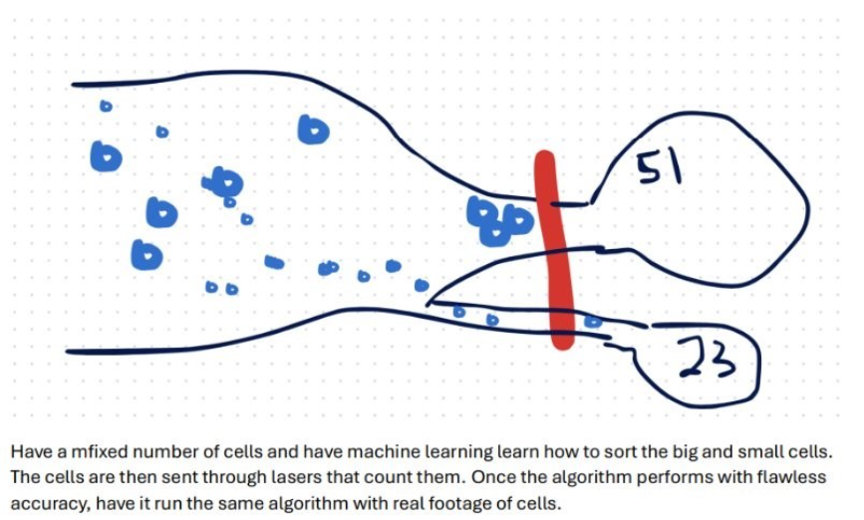
Figure 1: Brainstorm Idea 1, Counting Cells with Lasers
The next idea that was considered involved the use of the four-color theorem to separate all the cells and then categorize them by size and shape. The four-color theorem, which had been learned in Discrete Structures, states that any objects in a plane can be colored with at most four colors such that no two adjacent regions share the same color. While this concept inspired part of the final method, the theorem itself was not fully implemented.
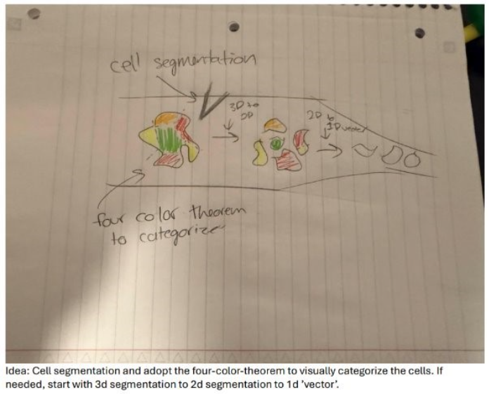
Figure 2: Brainstorming Idea 2, Four-Color-Theorem
The last method that was proposed involved expanding upon existing MATLAB code—either open-source or inherited from the previous Cell Imaging team. Although considered simple at first, this method was ultimately used in the final project decision.
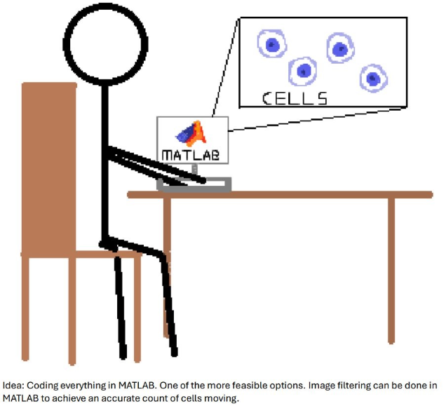
Figure 3: Brainstorm idea 3, MATLAB coding

Chapter 2: Initial Design
In this chapter, the constraints, criteria, standards, and final solution for the Cell Imaging 2026 Project will be outlined. The limitations that were considered during the design process will be described, along with the specific requirements that guided the system’s development. A decision matrix that was used to evaluate potential solutions will be presented, and the rationale behind the final approach will be discussed.

Constraints and Criteria
- Constraint 1: User Friendly
- Constraint 2: Discern Cell Boundaries in 2D Space with Accuracy
- Constraint 3: Design must be created in MATLAB and use the MATLAB workspace. ​
- Criteria 1: Affordable
- Criteria 2: Reproducible
- Criteria 3: Multi-Codec Compatibility
- Standard: MISRA (2023). MISRA C:2023: Guidelines for the use of the C language in critical systems. Nuneaton, UK: The MISRA Consortium Limited.

The most updated list of constraints, criteria, and engineering standards aimed to be met by this project is provided above. The list is tailored towards the MATLAB development solution, as the project proceeded with that solution.

Decision Matrix
Key:
Constraints: 1 — fails expectations, 3 — meets expectations, 5 — exceeds expectation
Criteria: Y — Yes, N — No
Solutions​ | Constraint 1:  User Friendly​ | Constraint 2:  Discern Cell Boundaries in 2D Space with Accuracy​ | Constraint 3: MATLAB workspace​ | Criteria 1:  Affordable​ | Criteria 2​: Reproducible | Criteria 3: Multi-Codec Compatibility | Total​
​Cell Segmentation with 4 color theory | ​3 | ​3 | ​2 | ​Y | ​Y | N | ​8
​Machine Learning | ​2 | ​5 | ​4 | ​N | ​Y | Y | ​11
​MATLAB Development | ​3 | ​3 | ​5 | ​Y | ​Y | Y | ​11
Table 1: Decision Matrix

Decision
The winning solution was “MATLAB Development”, continuing with the same method as the Cell Imaging 2025 Team. Instead of focusing on velocity and cell count, focus will be placed on size and shape, particularly observing cell deformation. This was decided as the winning solution because it is the only solution by which all three of our criteria were met. Further detail on how the design was tested against these constraints, criteria, and standards is provided in Chapter 3: Project Technical Details.

Solution Description
Initial sketches and thought processes of how the solution would work are discussed in this section. These are based on the design of how the Cell Imaging 2025 Team’s project functions. This information was collected during the conducted interviews. Images are processed through MATLAB in four distinct stages. In the first stage, the images are downloaded into MATLAB. In the second stage, all edges in the image are detected, although at this point it is not yet known whether each highlighted region represents a cell or the surrounding environment. In the third stage, cells are isolated from the background by applying a filter based on roundness, allowing borders to be removed and individual cells to be identified. In the final stage, the identified cells are recolored and overlaid onto the original image for visualization.
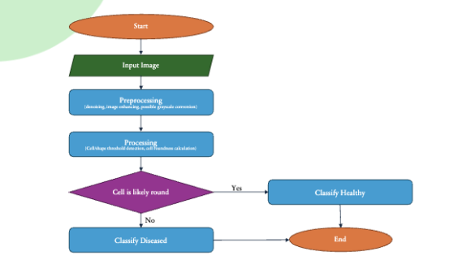
Figure 4: Descriptive initial thought of project flow chart

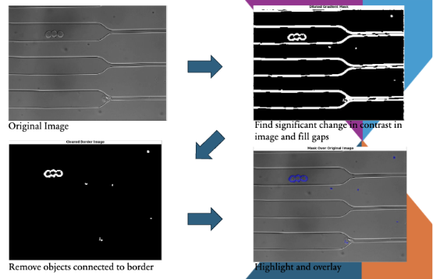
Figure 5: MATLAB example flowchart of cell counting
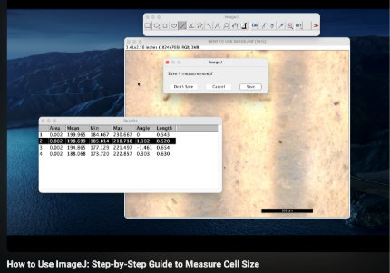
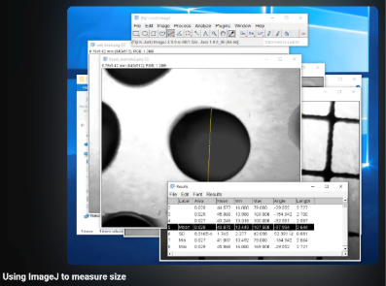
After this MATLAB processing is accurate and very replicable, the images will then be downloaded onto ImageJ. The project is not at this phase due to not completing the MATLAB section. However, there is a clear path that the group is planning to follow when it comes to the usage of ImageJ. Here are some examples of ImageJ’s user’s interface.
Figure 6: Example ImageJ software usage.
Again, these are low fidelity concepts of how the project may work, compared to existing user interfaces. Further details for the final solution’s design are provided in Chapter 3: Project Technical Details.

Chapter 3: Project Technical Details

Project Overview
You should have a basic description of your project here. Include a block diagram and describe any changes that were made to the design from the initial description in chapter 2. Be sure to give rationale for changes made (such as changes in design constraints, availability of components, unforeseen problems, etc)

Specifications
List all of your design specifications. This will include your constraints and criteria. It will also include all relevant engineering standards. It will also include specific requirements in your design such as wire gauge, power input, computing power, etc.
- Constraint 1: User Friendly
  - Design must be easy for first time users to use.
- Constraint 2: Discern Cell Boundaries in 2D Space with Accuracy
  - Design must be able to discern cell boundaries; Design must be able to parse object of interest and background.
- Constraint 3: Design must be created in MATLAB and use the MATLAB workspace. ​
- Criteria 1: Affordable
- Criteria 2: Reproducible
- Criteria 3: Multi-Codec Compatibility
- Standard: MISRA (2023). MISRA C:2023: Guidelines for the use of the C language in critical systems. Nuneaton, UK: The MISRA Consortium Limited.

The most updated list of constraints, criteria, and engineering standards aimed to be met by this project is provided above. The list is tailored towards the MATLAB development solution, as the project proceeded with that solution.

Testing Summary
The tests carried out to ensure all constraints, criteria, specifications, and standards have been met to a project-defined acceptable range are summarized in the table below.

Test | Passing Criteria | C/C/S/S (which one)
Second Sample Test | The code finishes from start to finish for both sample videos. Confirm with at least two different samples but ideally have as many samples as possible. | Criteria 2: Reproducibility
Ease of Usability Test | At least 95/100 trials get to the result screen without any errors. This ensures that the code is easy to use for all people. | Constraint 1: User-friendly
OS Compatibility Test | The code works without errors for at least 1 video container file type across at least 2 different operating systems (Windows, MacOS, Linux, Android). | Criteria 1: User-friendly
Standard Compliance Test | Every member of the team has their own notes on the code and understands it. The MISRA C standards are followed in our code. | Standard 1: Motor Industry Software Reliability Association (MISRA), Guidelines for the Use of the C Language in Critical Systems, MISRA C:2023. Nuneaton, UK: MISRA, 2023.
Deformation Rate Test | The test passes if the difference in aspect ratio is over 5%, showing a deformation. | Constraint 2: Discern Cell Boundaries in 2D space
MATLAB Test | The test passes if MATLAB is running, fails if any software other than MATLAB is running. | Constraint 3: Exclusive Use of MATLAB
Budget Test | The test passes if the total budget of materials is under $20. | Criteria 1: Affordable
Video Codec-Container Test | The test passes if, across different OS, multiple video codec containers (file types) can work without additional decoders needing to be installed. | Criteria 3: Multi-Codec Compatibility
Figure 7: Testing Summary of Criteria, Constraints, and Standards

Testing Plan
The testing plan outlines detailed procedures, materials, and pass/fail criteria to ensure the cell imaging system is accurate, user-friendly, and compatible across different environments. Multiple tests were conducted, including usability, OS compatibility, deformation accuracy, and video format support, with most passing successfully except for limitations related to certain video codecs on Windows systems. Results demonstrated high usability and reliable performance across operating systems and video inputs. Overall, the testing confirms that the system meets key design constraints and criteria, with minor improvements needed for cross-platform codec compatibility.

Second Sample Test
The second sample test will ensure that the code works for all potential users, varying camera qualities, and cells with different structures and properties. Since OS compatibility is not confirmed by this test, the test is considered passed even if the second sample test works on the same OS, which is the key distinction between the second sample test and the video codec-container test.

Materials:
- Two sample videos with different video file containers.
  - Example: “movie1.mp4” & “movie2.mov”.
  - A video file’s file container is represented by its file extension, e.g. “.mp4”.
- MathWorks® MATLAB Software (Standard License).
- Most recent version of the project code.

Instructions
- Save your two sample cell imaging videos in a known directory.
- Save the most recent version of the project code in a known directory.
- Open project code in MathWorks® MATLAB.
- Run Active Code file (The project code just opened).
- Navigate to the first sample video. Upload the first sample video into code.
- Run code to completion to ensure no execution failures.
  - This includes opting into any optional features. When prompted with “Remove duplicate frames before analysis?”, Select “Yes”. When asked to enter a calibration scale and an acquisition frame rate, enter known values (if applicable) or fabricate reasonable values to ensure the project runs to completion.
  - “Completion” means that the user is given an output of data in the Command Window.
- Repeat steps 4-6 with the second sample video.
Pass/Fail Criteria: This test passes if the code execution finishes, from start to finish, with two different videos of different file container formats.

Results
This test was passed, and the code was run successfully on MacOS 15 Sequoia with videos titled “c3lc50427a.wmv” and “c3lc50427a_nodup_30fps.mp4”. These have two different video containers.

Ease of Usability Test
The ease of usability test will verify the constraint of having to be user friendly. It will ensure that people who have no background in MATLAB or cell imaging can use it as a tool if the need for it comes up.

Materials:
- 100 People.
  - Researchers, graduate/undergraduate students focus on biology/cells, students not focused on biology/cells, miscellaneous students, campus tourists, average citizens, etc.
- Two separate hardware devices running different OS.
  - This test was done with one device running MacOS 15 Sequoia and one device running Windows 11 Pro 24H2.
- MathWorks® MATLAB Software (Standard License).
- Most recent version of the project code.
- Cell Imaging video demonstrating cell deformation (like “c3lc50427a.wmv” provided in the project files).

Instructions
- Save a cell imaging video and the most recent version of the project code in a known directory on both devices.
- Have users open and run the code to completion.
  - Open project code in MathWorks® MATLAB on one of the hardware devices
  - Run Active Code file (The project code just opened).
  - Navigate and upload the cell imaging video.
  - Run code to completion to ensure no execution failures.
    - Answer any yes or no questions the user may ask, but do not instruct te user further.
    - Users may opt in or opt out of any optional features.
    - “Completion” means that the user is given an output of data in the Command Window.
- Run 50 trials with one hardware device.
- Repeat steps 3-5 with the other hardware device, running the same version of the code and the same cell imaging video.
- Record results.
Pass/Fail Criteria: This test passes if 95% of the tested users execute the project code without errors or major stopping points of confusion. There must be output data in the MATLAB command window.

Results
This test was passed, as 96/100 trials completed to succession without runtime errors or user confusion. The code was run successfully on for 49/50 trials on MacOS 15 Sequoia and 47/50 Windows 11 Pro 24H2 with videos titled “c3lc50427a.wmv”. Results are listed below.
Did users “successfully” execute the project?
Windows 11 Pro 24H2 |  |  |  | MacOS 15 Sequoia
Trial 1 | Yes | Trial 26 | Yes | Trial 1 | Yes | Trial 26 | Yes
Trial 2 | Yes | Trial 27 | Yes | Trial 2 | Yes | Trial 27 | Yes
Trial 3 | Yes | Trial 28 | Yes | Trial 3 | Yes | Trial 28 | Yes
Trial 4 | Yes | Trial 29 | Yes | Trial 4 | Yes | Trial 29 | No
Trial 5 | Yes | Trial 30 | Yes | Trial 5 | Yes | Trial 30 | Yes
Trial 6 | Yes | Trial 31 | Yes | Trial 6 | Yes | Trial 31 | Yes
Trial 7 | Yes | Trial 32 | Yes | Trial 7 | Yes | Trial 32 | Yes
Trial 8 | Yes | Trial 33 | Yes | Trial 8 | Yes | Trial 33 | Yes
Trial 9 | Yes | Trial 34 | Yes | Trial 9 | Yes | Trial 34 | Yes
Trial 10 | Yes | Trial 35 | Yes | Trial 10 | Yes | Trial 35 | Yes
Trial 11 | Yes | Trial 36 | Yes | Trial 11 | Yes | Trial 36 | Yes
Trial 12 | Yes | Trial 37 | Yes | Trial 12 | Yes | Trial 37 | Yes
Trial 13 | Yes | Trial 38 | Yes | Trial 13 | Yes | Trial 38 | Yes
Trial 14 | Yes | Trial 39 | Yes | Trial 14 | Yes | Trial 39 | Yes
Trial 15 | No | Trial 40 | Yes | Trial 15 | Yes | Trial 40 | Yes
Trial 16 | Yes | Trial 41 | Yes | Trial 16 | Yes | Trial 41 | Yes
Trial 17 | Yes | Trial 42 | No | Trial 17 | Yes | Trial 42 | Yes
Trial 18 | Yes | Trial 43 | Yes | Trial 18 | Yes | Trial 43 | Yes
Trial 19 | Yes | Trial 44 | Yes | Trial 19 | Yes | Trial 44 | Yes
Trial 20 | Yes | Trial 45 | Yes | Trial 20 | Yes | Trial 45 | Yes
Trial 21 | Yes | Trial 46 | Yes | Trial 21 | Yes | Trial 46 | Yes
Trial 22 | Yes | Trial 47 | Yes | Trial 22 | Yes | Trial 47 | Yes
Trial 23 | Yes | Trial 48 | No | Trial 23 | Yes | Trial 48 | Yes
Trial 24 | Yes | Trial 49 | Yes | Trial 24 | Yes | Trial 49 | Yes
Trial 25 | Yes | Trial 50 | Yes | Trial 25 | Yes | Trial 50 | Yes
Table 2: Ease of Usability Full Trial Results
Ease of Usability Test Results
Successful Trials (MacOS) | 49
Unsuccessful Trials (MacOS) | 1
Successful Trials (Windows) | 47
Unsuccessful Trials (Windows) | 3
Total Trials | 100
Table 3: Ease of Usability Trial Result Summary

OS Compatibility Test
One of the most expensive materials for this project is the hardware. The OS (operating system) compatibility test will ensure that compatibility with any OS is achieved to minimize the need for new hardware to be purchased or for existing hardware to be partitioned to install a compatible OS. This test will not test compatibility for all video file containers and will be passed if the code is run with at least 1 file container type.

Materials:
- Two separate hardware devices running different OS.
  - This test was done with one device running MacOS 15 Sequoia and one device running Windows 11 Pro 24H2.
  - Could run any OS compatible with MATLAB: Windows, MacOS, Linux, etc.
- MathWorks® MATLAB Software (Standard License).
- Most recent version of the project code.
- Cell Imaging video demonstrating cell deformation (like “c3lc50427a.wmv” provided in the project files).

Instructions
- Save a cell imaging video and the most recent version of the project code in a known directory on both devices.
- Open project code in MathWorks® MATLAB.
- Run Active Code file (The project code just opened).
- Navigate and upload the cell imaging video.
- Run code to completion to ensure no execution failures.
  - This includes opting into any optional features. When prompted with “Remove duplicate frames before analysis?”, Select “Yes”. When asked to enter a calibration scale and an acquisition frame rate, enter known values (if applicable) or fabricate reasonable values to ensure the project runs to completion.
  - “Completion” means that the user is given an output of data in the Command Window.
- Repeat steps 2-5 with the other hardware device, running the same version of the code and the same cell imaging video.
Pass/Fail Criteria: The code passes if it executes without errors for at least 1 video container file type across at least 2 different operating systems (Windows, MacOS, Linux, Android, etc).

Results
This test was passed as described by the Pass/Fail criteria. An example output is shown in the figure below:
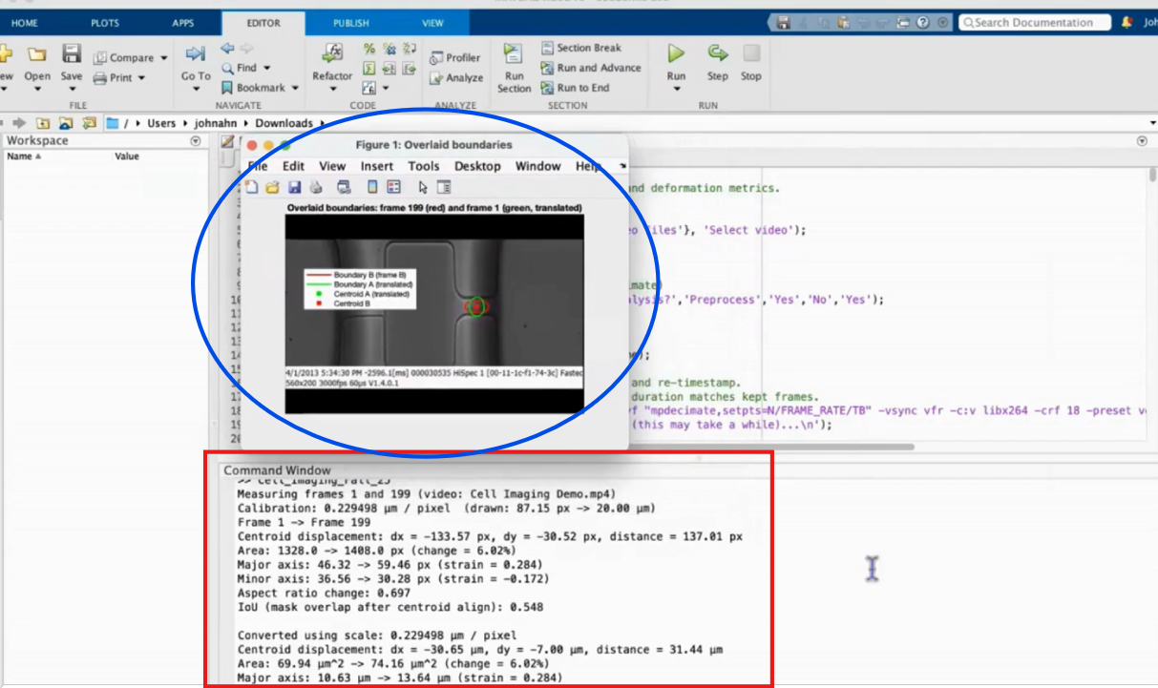
Figure 8: Example of output shown at end of MATLAB program

Standard Compliance Test
The compliance test ensures that the code file follows the set of standards provided by MISRA (Motor Industry Software Reliability Association). Though the coding practices were initially targeted in the automobile industry, it is widely accepted for other industries like aerospace, industrial, and medical devices.

Materials:
- https://www.mathworks.com/help/bugfinder/misra-c-2023-reference.html
  - MISRA C Standard (for reference)
- One hardware device.
  - Could run any OS compatible with MATLAB: Windows, MacOS, Linux, etc.
- MathWorks® MATLAB Software (Standard License).
- Most recent version of the project code.
- Something for note taking.
  - Physical notes, Word document, OneNote page, etc.

Instructions
- Read through MIRSA C Standard, noting any major conventions to follow.
- Open most recent version of the project code in MATLAB.
- Read through each line of code and ensure it follows the standard
  - Add comments for clarification
  - Correct any naming conventions
- Record detailed notes for personal use
Pass/Fail Criteria: This test passes if every member of the team has their own notes on the code and understands it, ensuring that The MISRA C standards are followed in the project code as closely as possible.

Results
This test was passed as described by the Pass/Fail criteria above. Member notes of the program code as of October 2025 can be found in “Cell Imaging > Fall 2025 > Midterm Prep and Notes”.
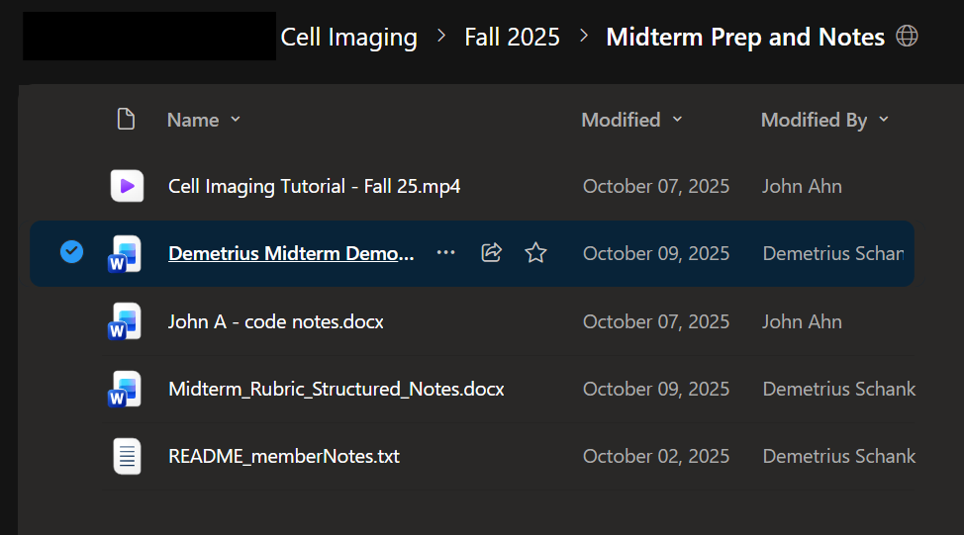
Figure 9: Team Member User Notes Directory

Deformation Rate Test
The deformation rate test ensures that the deformation measurements made by the code are accurate. This test is mainly for the ideal scenario where the code is fully automated, so for the time being the two compared measurements will be those drawn using the most recent version of the code and those measured manually. The latter measurements may be measured using AI tools.

Materials:
- One hardware device.
  - Could run any OS compatible with MATLAB: Windows, MacOS, Linux, etc.
- MathWorks® MATLAB Software (Standard License).
- Most recent version of the project code.

Instructions
- Save a cell imaging video and the most recent version of the project code in a known directory on both devices.
- Open project code in MathWorks® MATLAB.
- Run Active Code file (The project code just opened).
- Navigate and upload the cell imaging video.
- Run code to completion to ensure no execution failures.
  - Take the measurements of the two frames, and look at the inspector where all the measurements are given
  - With the same two selected frames, have any AI take the measurements and produce the percentage it differs from the one you measured.
  - This includes opting into any optional features. When prompted with “Remove duplicate frames before analysis?”, Select “Yes”. When asked to enter a calibration scale and an acquisition frame rate, enter known values (if applicable) or fabricate reasonable values to ensure the project runs to completion.
  - “Completion” means that the user is given an output of data in the Command Window.
Pass/Fail Criteria: The test passes if the difference in aspect ratio is over 5%, showing a deformation.
Here is a quick sample of what it may look like:
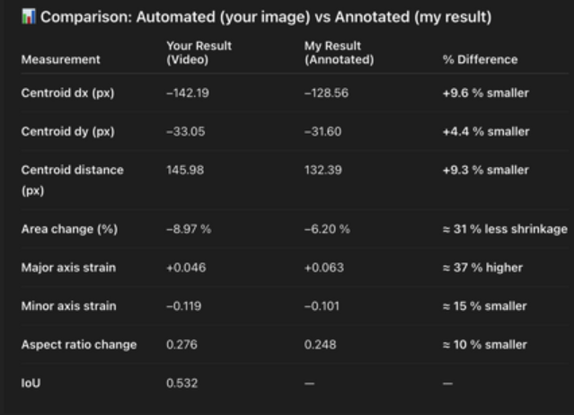
Figure 10: Simulated Deformation Rate Trial Run (Before vs. After Comparison)

Results
WRITE HERE!!!!!!
(old) This test passes, as when doing a trial run of the program on the esi_movie it detected an aspect ratio change of 11%, which is greater than 5%. This test is needed to capture the accuracy and purpose of the program. Our constraint was that the program would be able to discern cell boundaries in 2D space, which the deformation rate test ensures by detecting if the boundaries change in any way, whether it is larger or smaller by at least 5%.

MATLAB Test
The MATLAB test ensures that the project exclusively uses MATLAB.

Materials:
- One hardware device.
  - Could run any OS compatible with MATLAB: Windows, MacOS, Linux, etc.
- MathWorks® MATLAB Software (Standard License).
- Most recent version of the project code.
- Cell Imaging video demonstrating cell deformation (like “c3lc50427a.wmv” provided in the project files).

Instructions
- Save a cell imaging video and the most recent version of the project code in a known directory on both devices.
- Quit all unneeded programs running (from Task Manager, Activity Monitor, etc.) on the hardware device.
- Open project code in MathWorks® MATLAB.
- Run Active Code file (The project code just opened).
- Navigate and upload the cell imaging video.
- Run code to completion to ensure no execution failures.
  - This includes opting into any optional features. When prompted with “Remove duplicate frames before analysis?”, Select “Yes”. When asked to enter a calibration scale and an acquisition frame rate, enter known values (if applicable) or fabricate reasonable values to ensure the project runs to completion.
  - “Completion” means that the user is given an output of data in the Command Window.
Pass/Fail Criteria: The test passes if MATLAB is running, fails if any software other than MATLAB is running.

Results
This test was passed as described in the pass/fail criteria above. No other software is required to be running at the same time as MATLAB. Additional software packages may need to be installed (refer to Parts and Components) but are not required to be running at program execution.

Budget Test
The budget test ensures that the actual cost to users is below $20 USD.

Materials:
- One hardware device.
  - Could run any OS compatible with MATLAB: Windows, MacOS, Linux, etc.
- MathWorks® MATLAB Software (Standard License).
- Most recent version of the project code.
- Cell Imaging video demonstrating cell deformation (like “c3lc50427a.wmv” provided in the project files).

Instructions
- Calculate the total cost of all materials needed to run this project that is not already owned.
Pass/Fail Criteria: The test passes if the total actual budget of materials is under $20 USD.

Results
This test passes as the total actual budget for this project is under $20 USD. Refer to Budget.

Video Codec-Container Test
The video codec-container test ensures that the code works with different video containers on different operating systems.

Materials:
- Two sample videos with different video file containers.
  - Example: “movie1.mp4” & “movie2.mov”.
  - A video file’s file container is represented by its file extension, e.g. “.mp4”.
- Two separate hardware devices running different OS.
  - This test was done with one device running MacOS 15 Sequoia and one device running Windows 11 Pro 24H2.
  - Could run any OS compatible with MATLAB: Windows, MacOS, Linux, etc.
- MathWorks® MATLAB Software (Standard License).
- Most recent version of the project code.

Instructions
- Open/power on hardware devices. Set one aside.
- Save your two sample cell imaging videos in a known directory.
- Save the most recent version of the project code in a known directory.
- Open project code in MathWorks® MATLAB.
- Run Active Code file (The project code just opened).
- Navigate to the first sample video. Upload the first sample video into code.
- Run code to completion to ensure no execution failures.
  - This includes opting into any optional features. When prompted with “Remove duplicate frames before analysis?”, Select “Yes”. When asked to enter a calibration scale and an acquisition frame rate, enter known values (if applicable) or fabricate reasonable values to ensure the project runs to completion.
  - “Completion” means that the user is given an output of data in the Command Window.
- Repeat steps 5-7 with the second sample video on the same OS.
- Repeat steps 2-8 on the second hardware device with the different OS.
Pass/Fail Criteria: This test passes if the code execution finishes, from start to finish, with two different videos of different file container formats across different OS. Multiple video codec containers (file types) can work without additional decoders needing to be installed.

Results
This test failed, as when a .avi video file is run on some Windows-based machines. The following error was given when a video titled “esi_movie3.avi” was being run:

Error using VideoReader/initReader
The file requires the following codec(s) to be installed on your system:
cvid
“cvid” is the Cinepak codec. The codec is natively installed on most Apple machines due to Apple QuickTime. To install the codec on a Windows machine, “K-Lite Codec Pack Standard” must be installed, in which the Cinepak codec is bundled. K-Lite Codec Pack Standard is a free, comprehensive collection of components for Microsoft Windows by which playback of many audio and video formats is enabled. By this installation, it is also ensured that other untested video formats can be processed properly on the Windows device.
Although an additional installation step is introduced for some Windows users by this requirement, a financial barrier is not created, and the base functionality of the algorithm itself is not affected. It is indicated by the results that the limitation lies in operating system-level codec support rather than MATLAB or the project’s internal logic. Future improvements could include automatic codec detection, clearer user warnings, or recommended file format conversions by which cross-platform reliability may be improved.

Schematics and Drawings
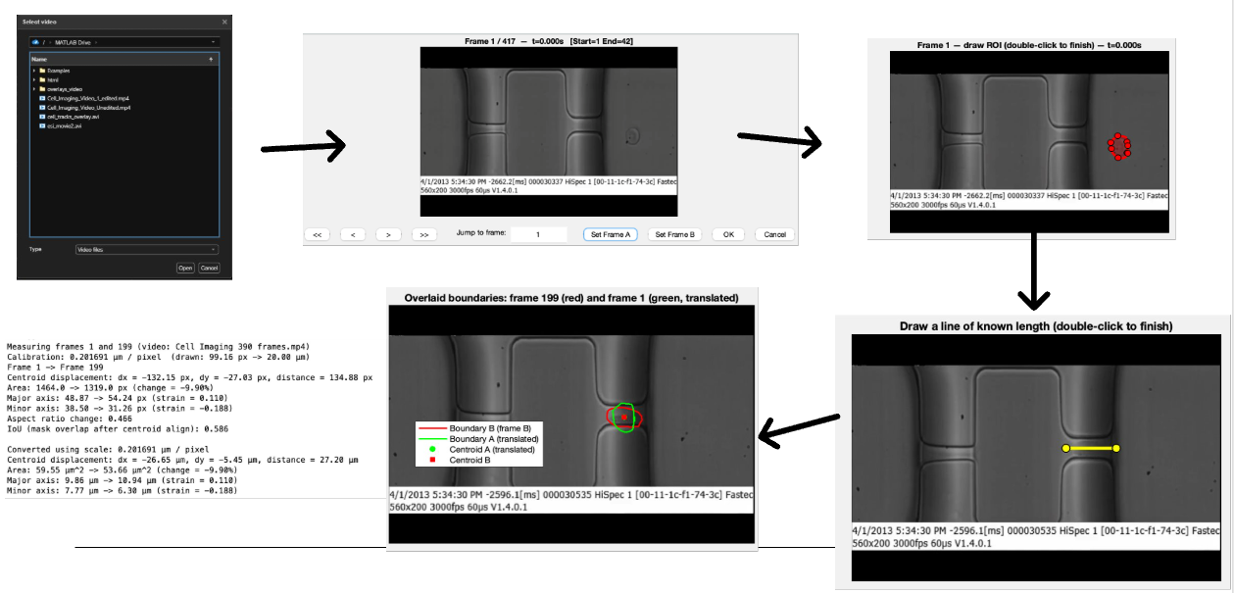
Figure 11: Final Project Flowchart with MATLAB examples
Start Program à Input Video à Select two Frames using Frame Browser à Draw the ROIs à Add an optional Calibration Line à Results à End Program

Client Materials
The prototype is designed to be simple to operate. The required materials are MATLAB software, the project’s MATLAB code, and a video of cells deforming over time. When the program is started, a file upload prompt is displayed, after which a video is selected and uploaded. Optional features are then prompted, including the option to remove duplicate frames before analysis using the ffmep toolbox. Inputs such as calibration scale and acquisition frame rate may be entered if known or reasonably estimated. This tool was used to shorten the video used during the live demonstration from 3k frames to 1k frames.
Two frames are then selected using “Frame A” and “Frame B,” after which an ROI (region of interest) is drawn on each frame, with the option for it to be redrawn if needed. Pixel-to-micron conversion may be performed if a known measurement is provided. Upon completion, the centroids of the two drawn frames are aligned. The command window shows measurements, including: centroid displacement (how far the centroid was moved), area change (total size change, negative value shows slight shrinkage), maojr and minor axis strains (length and height, stretch or squeezed), aspect ratio change (positive means more oval, negative means more round), and the iou, the intersection over union (how much of the two ROIs overlap with each other).

Please refer to the Testing Plan for specific instructions on how to run the code.

Project files can be found on Villanova’s OneDrive here: Cell Imaging 2026 OneDrive Link
Project files can be found on GitHub here: LATER

Chapter 4: Broader Impacts

Public Health, Safety, and Welfare
The cell imaging analysis design is expected to positively impact public health by improving the efficiency of cell deformation measurements through capillaries. By enabling deformation to be measured using MATLAB video analysis instead of manual segmentation and observation, repeatable results can be obtained. Improved accuracy in cell deformation measurements is sought to support biomedical research applications, such as disease diagnosis (e.g. sickle cell anemia), cellular response analysis, shear stress through capillaries, and drug testing. As a result, advancements in medical treatments and diagnostic techniques may be supported, which contributes to improved public health outcomes. Public welfare is impacted by the increased accessibility of analytical tools. The limitation to software-based image processing in MATLAB reduces the need for expensive laboratory equipment. Because the design relies on existing computing hardware and licensed software that target audience may already have provided, the barrier for entry for research is reduced. Public safety risks are minimal because no direct interaction with patients, biological hazards, or medical treatment systems is required. The system operates using recorded lab video datasets. The gathering of data is not concerned in this project. Primary risks identified are related to software reliability, data accuracy, and system functionality. These risks were determined through evaluation of the subsystems, including video codec compatibility and hardware reliability.

Global, Cultural, and Social
The cell imaging analysis design is expected to impact global research and accessibility. By studying deformation measurements through MATLAB based video analysis, research workflows can be shared more easily across institutions. This increased accessibility is held as a primary goal of the project. Because the system operates on MATLAB based processing and on different digital video formats, analysis methods can be distributed electronically, supporting research institutions with limited equipment. Cultural and societal impacts are reflected in this increased accessibility. This design also supports the a broader societal goal of advancing biomedical knowledge. Improved efficiency and repeatability in cell deformation analysis contributes to global research areas previously mentioned in the Public Health, Welfare, and Safety section.
One ethical issue involves unequal access to required software and technical resources. Because the design relies on licensed MATLAB software, access is limited to institutions or individuals that can obtain and maintain the MATLAB license. Another ethical concern involves the potential misuse or misrepresentation of shared analytical methods across different research environments. If the system is sued without proper understanding of its limits, incorrect conclusions may be produced. Consideration was also given to intellectual property and proper software use. Licensed software and external codecs were used in accordance with their intended licensing agreements. Responsibility was taken by ensuring that only properly licensed tools were used during development and that the system design did not include unauthorized redistribution of protected software. These actions were taken to support ethical use of technology across global and societal contexts.

Environmental
One ethical concern involves the potential misuse of analysis results. If deformation measurements are inaccurate, incorrect conclusions about cell behavior could occur. This could negatively impact research quality or future medical decisions; therefore, the output results are properly labeled. Another ethical concern involves intellectual property and software licensing. MATLAB and the used toolboxes are licensed software; thus, proper licensing must be maintained. Unauthorized distribution or misuse of licensed software would violate intellectual property rights. Responsibility was taken by the team to mitigate these ethical concerns by maintaining proper software licensing and using reliable, open-source tools/codec packs. Also, the system was designed strictly as a research support tool rather than as a diagnostic medical device, which reduces the risk of harm from unintended use.

Economic
A cheaper and faster method of cell imaging can drive new innovations into healthcare, which will allow better and more affordable diagnosis and treatment. The design was purposeful in reducing the labor hours that previous healthcare professionals had to go through. Previously, to measure the deformation, healthcare professionals had to measure each picture hand by hand, which would take many hours. The alternative method would be to purchase a specialized device that costs thousands of dollars to perform the calculations. The design in the future hopes to reduce the hours done by medical professionals, and reduce the potential costs to measuring cell deformation, while maintaining a degree of reliability.
One ethical issue with introducing this design into the economy is it can change the decision-making of medical professionals. When there is a free, quick, alternative to the hours of hand drawing done by medical professionals or the costly medical devices, the medical professionals may move from their quality methods to a method that is still under development. The team took responsibility in saying that the design is still under development, and the output results are not for medical use. Another ethical issue is that while advertised as “free-use” it is technically not free as it is under the MATLAB licensing. Though the software may be free for some users under institutional use, for medical professionals the software may cost some amount of money, leading to an unintentional advertising of MATLAB software.

Engineering Standards
Standard used: Motor Industry Software Reliability Association (MISRA), Guidelines for the Use of the C Language in Critical Systems, MISRA C:2023. Nuneaton, UK: MISRA, 2023.
The MISRA C:2023 standards are a set of coding guidelines. These guidelines are important because undefined behavior or ambiguous values can happen without these guidelines. Unexpected values can potentially rise to become a bigger issue if not taken account of. A simple error of a value being a 1 when it could be 2 because of evaluation order could lead to inaccuracy. The total rules contained in MISRA:C is at least 4 directories and 23 rules. Meeting the standards is done by using the Polyspace tool. Polyspace can run a static analysis on MATLAB code with the MISRA C guidelines and determine whether the directories/rules are compliant or noncompliant. Our project meets the standards through the use of this tool.

Risk Assessment
The project design is considered to provide greater benefits than risks when implemented, as improvements in accessibility, efficiency, and repeatability of cell deformation analysis are enabled through MATLAB-based processing. Faster and more consistent measurements are supported compared to manual segmentation, and reduced reliance on expensive imaging hardware is achieved. However, several risks have been identified. Software-related risks are introduced through potential instability in video codec compatibility, OS-dependent execution behavior, and reliance on MATLAB toolboxes and licensed components. Data-related risks are also present, as inaccurate input values, improper calibration, or inconsistent video quality may lead to incorrect deformation measurements and misleading outputs. In addition, usability risks are introduced when optional features such as calibration scaling or frame selection are misused or misunderstood by first-time users.
These risks are mitigated through structured testing across multiple operating systems and video formats, including the OS compatibility and video codec-container tests, which verify cross-platform functionality. Usability risks are reduced through a simplified workflow, optional feature prompts, and clear pass/fail criteria requiring successful output generation in the MATLAB Command Window. Data accuracy risks are addressed by allowing manual verification of measurements and optional comparison using external tools. Furthermore, system limitations are explicitly documented to prevent misuse in medical or diagnostic contexts, and the design is maintained as a research-support tool rather than a clinical system.

Chapter 5: Project Management

Schedule
In this section, the overall project schedule is discussed.

Planned Schedule (Spring25 Cell Imaging Gantt Chart)
Below a rough draft of the Gantt chart that will be followed during the entirety of this project.

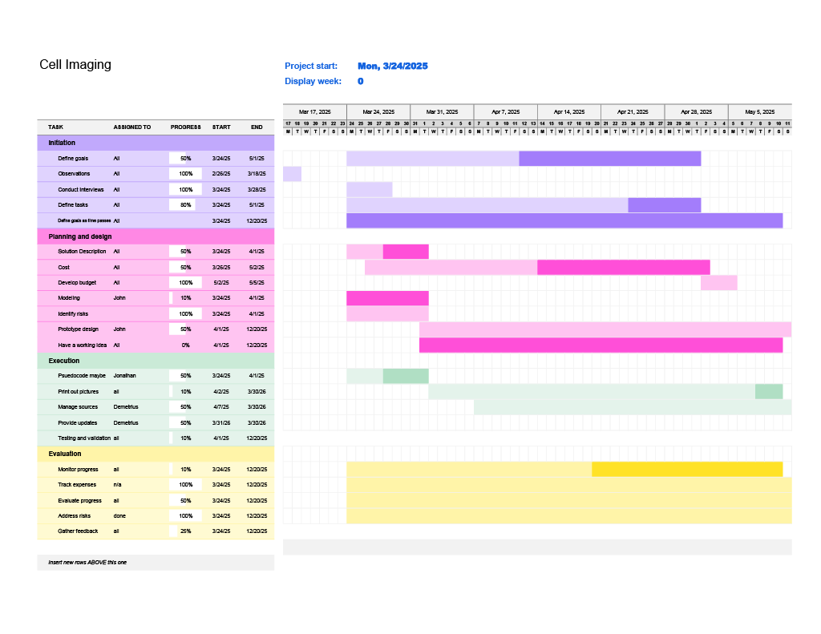
Figure 12: Planned Gantt Chart (Spring25)

The project is split into four parts from start to finish. The stages are research, coding implementation, testing and reiteration, and release once the product is at an acceptable accuracy rate is achieved.

Actual Schedule (Spring26 Cell Imaging Gantt Chart)
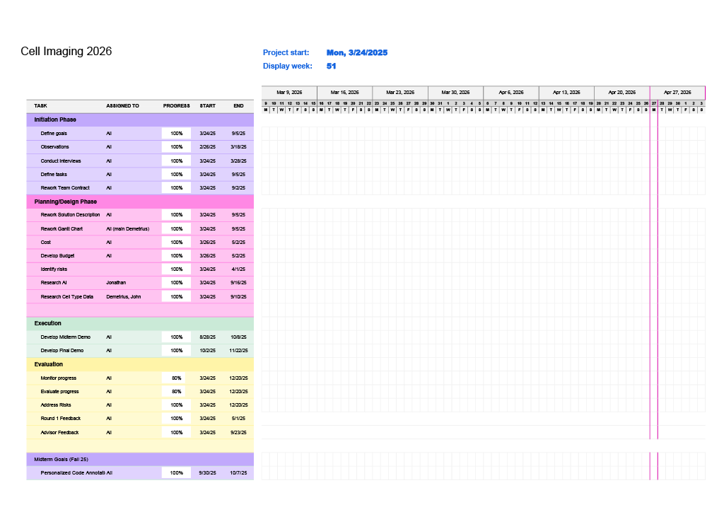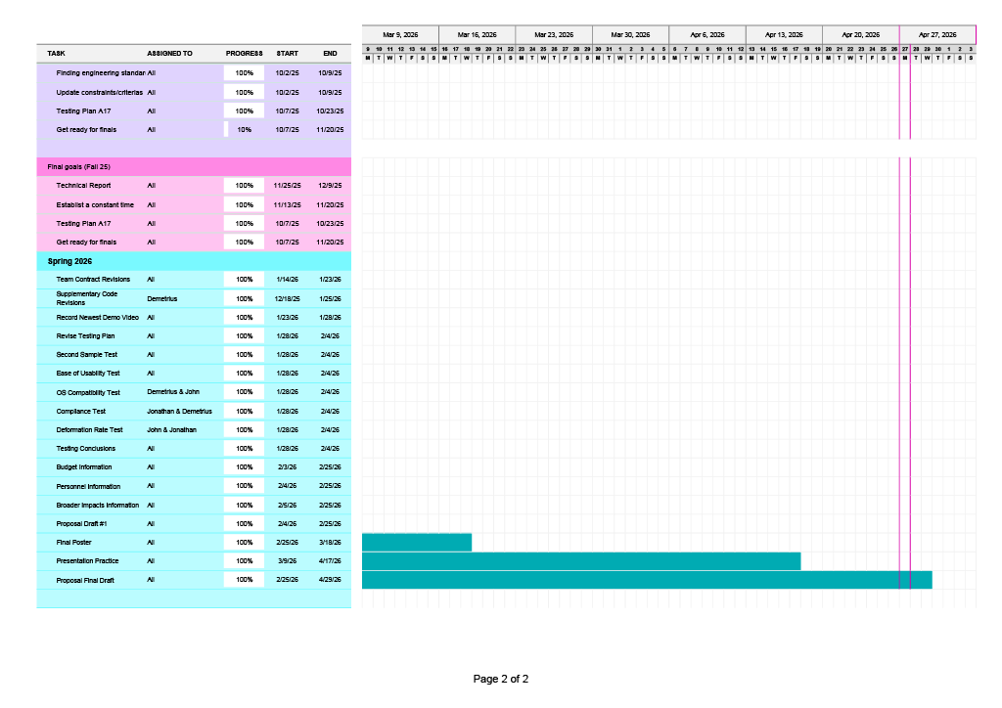
Figure 13: Final Gantt Chart (Spring26)

Schedule Discussion
No major discrepancies were encountered during task completion. Testing required more time than initially anticipated, as additional test cases were developed to improve isolation and targeting of independent variables. For example, the Video Codec-Container Test was introduced to specifically evaluate video codec compatibility across different operating systems. Initially, the Second Sample Test also incorporated codec compatibility checks, in addition to verifying whether a second sample could be executed successfully on the same operating system. However, this overlap was later resolved by separating the objectives of the two tests. As a result, successful completion of the Second Sample Test is required prior to the execution and validation of the Video Codec-Container Test to ensure independent assessment of system functionality.
Throughout the duration of the project, the initial planned schedule has been significantly expanded in both size and detail of the tasks. The initial “Spring25 Cell Imaging Gantt Chart” contained tasks limited to the scope of the Spring 2025 semester. Early in the development stage, the trajectory of the project was difficult to predict, and therefore the project’s main goals were laid out very vaguely. In this older schedule, typographical discrepancies are present in the Execution portion, and all years were intended to be 2025, although some project end dates were mistakenly extended into the Spring 2026 semester.
In the newest schedule, “Spring26 Cell Imaging Gantt Chart”, the initial goals were reworked to eliminate redundancy. To accurately reflect the past schedules, a handful of the original task descriptions were not renamed, while any future new tasks added to the schedule were made more specific, as seen in the Spring 26 portion of the “Spring26 Cell Imaging Gantt Chart”.

The most updated, completed version of the schedule may be found in the directory listed here:
“…Cell Imaging > Spring 2026 > Spring26 Cell Imaging Gantt Chart.xlsx”.

Personnel
John Ahn - 3D print, can help with MATLAB
John is the manager of the Gantt chart. He enjoys designing and 3D printing, so he oversees designing a physical prototype (if the group decides to go into it). He has little background in MATLAB, so he’ll be assisting Jonathan with it.

Demetrius Schank -
Demetrius brings a strong work ethic to the team, really driving the team to think about the project as often as possible. He is detail oriented and thus needs to gather a lot of information to feel ready to tackle a project. This makes him a great candidate to be the head of research for the team. With the work the team has done so far, it is clear the team needs someone to drive the team towards a narrower focus. In this role, he is responsible for providing that tunnel focus—which datasets the team should use, and which characteristics should the team be trying to test for. He is not responsible for all the research, rather for being a pillar for the team’s research.

Jonathan Kim -
Jonathan brings his experience of MATLAB coding to the table, easing the team to code in this language. While he will not be the sole coder of the team, he can be one to find methods to lead the others to do. If the group decides to go physical, he can help with wiring and electronic devices/systems.

Member Labor Hours
Person | John Ahn | Jonathan Kim | Demetrius Schank
Spring25 Hours  (estimate) | 15 | 15 | 15
Fall25 Hours | 31 | 30.25 | 36.75
Total | 46 | 45.25 | 51.75
Table 4: Member Labor Hours Summary

Parts and Components
MATLAB License
Made by MATLAB, with the company’s headquarters stationed in Natick, MA. Three licenses were necessary, one for each member of the group. These licenses were provided by Villanova University’s campus-wide license for MATLAB. These licenses are renewed every year by Villanova University. Without the sponsored licenses, the individual licenses could have a cost of $119-$165. Three licenses are required for this project, one for each team member.

Hardware - Windows OS
Hardware capable of running the Windows OS is manufactured by various companies. For the purposes of this assignment, the component is represented by a Windows OS laptop sold by Dell Technologies. Various Windows OS laptop devices are built and sold by Dell Technologies, each offering different capabilities and price points. A cost of $800 is estimated for a Windows OS laptop suitable for this project. Dell Technologies is headquartered in Round Rock, Texas.

Hardware - MacOS
Hardware capable of running the MacOS is manufactured by Apple Inc. Various MacOS laptop devices are built and sold by Apple Inc., each offering different capabilities and price points. A cost of $800 is estimated for a MacOS laptop suitable for this project. Apple Inc. is headquartered in Cupertino, California.

Skills and Tools
Image Processing Toolbox
The main toolbox used in our project, able to draw a mask, region of interest, and analyze multiple regions of interest to compare.

FFmpeg Toolbox
Optional toolbox used to remove duplicate frames from a video. This toolbox was used with the future goal in mind to obtain a constant time value to eventually calculate deformation rate.

K-Lite Codec Pack Standard
K-Lite Codec Pack Standard is a free collection of audio and video codecs for Windows systems that enable the playback and processing of various media formats. Codecs such as Cinepak (“cvid”) are included so that video files requiring specific decoding methods can be properly read by a system. It is used in this project to ensure that .vi and other codec-dependent video files can be processed without runtime errors, allowing deformation analysis to be performed as intended.

Budget
The budget is calculated using the worst-case cost scenario, particularly for the MATLAB license. Industry “Tool Overhead Cost” are calculated via the following criteria:

- $0.16 per kWh for Villanova PA Electricity Cost. Assume 2.25 kWh usage per hour per member.
  - Total Electricity Cost = $51.48
- $0.03 other utility costs per hour per member.
  - Total Other Utility Costs = $4.29
Industry “Salary Overhead Cost” is calculated via the following criteria:
- $25 per hour for custodial staff for used public spaces for max labor hours of a member (x2)
  - Total Custodial Cost (for 2 custodians) = $2587.50

Industry “Member#X Labor Cost” is calculated as the following:
- $25 per hour wage for each member labor hour
  - Example: Member #1: 46 hours * $25 USD per hour = $1150 USD

 | Industry cost ($) | Actual cost ($)
Hardware Part Costs | 1600.00 | 0.00
MATLAB License | 1050.00 | 0.00
Tool Overhead Cost | 55.77 | 0.00
Salary Overhead Cost | 2587.50 | 0.00
Member #1 Labor Cost | 1150.00 | 0.00
Member #2 Labor Cost | 1131.25 | 0.00
Member #3 Labor Cost | 1293.75 | 0.00
Villanova’s Overhead  (federal) | 0.00 | 0.00
Total | 8868.27 | 0.00
Table 5: Industry Cost vs. Actual Cost

Chapter 6: Achievements and Conclusions

Achievements
Give a summary of your achievements. What did you accomplish during this project? Be clear about what worked and what did not work. Refer to earlier sections.

Throughout the duration of the project, a MATLAB-based system for detecting and analyzing cell deformation from microscopy videos was successfully developed and tested. Cell boundaries were identified through image processing techniques, and deformation between selected frames was measured using metrics such as aspect ratio change, centroid displacement, and strain along the major and minor axes. A complete workflow was established in which a user is prompted to upload a video, select frames, define regions of interest, and obtain quantitative outputs directly in the MATLAB Command Window. This workflow was shown to function reliably across multiple trials and datasets, including development and testing using the video dataset “c3lc50427a.wmv,” which was obtained from the work by Zheng et al. [15].
The Image Processing Toolbox was used as the primary component for analysis within the code. Functions such as grayscale conversion, region-of-interest masking, and region property extraction were utilized to isolate and quantify cell characteristics. Measurements including area, centroid location, major and minor axis lengths, and perimeter were obtained using these tools. These capabilities were essential for computing deformation metrics and were observed to work consistently across different inputs. The toolbox enabled direct interaction with image data, allowing users to manually refine selections, which contributed to accuracy but also introduced user-dependent variability.
The FFmpeg toolbox was incorporated as an optional preprocessing step to improve data quality. Duplicate frames were optionally eliminated prior to analysis, which ensured that time-based measurements were more meaningful. This feature was observed to work effectively when the external FFmpeg command executed successfully. However, this step introduced a dependency on external software, and failures were encountered when FFmpeg was not properly installed or configured on the system. In such cases, the code was designed to proceed with the original video, which maintained functionality but reduced preprocessing effectiveness.
The K-Lite Codec Pack Standard was required in certain cases to resolve video playback and decoding issues, particularly on Windows-based systems. While video files such as .mp4 and .mov were generally supported natively, .avi files requiring the Cinepak (“cvid”) codec were not supported without additional installation. As a result, execution failures were encountered when unsupported codecs were used, as observed in the Video-Codec Container Test. This issue was resolved by installing the K-Lite Codec Pack, which provided the necessary decoding capabilities. Although this solution was effective, it introduced an additional setup requirement for some users, which reduced overall ease of use. It was determined that this limitation was not caused by the algorithm itself, but rather by operating system-level codec support.
Several aspects of the system were demonstrated to work well. The user interface flow was observed to be intuitive, as most users were able to complete execution without prior MATLAB experience. The deformation calculations were consistent and reproducible across multiple test cases, particularly when applied to the referenced dataset from Zheng et al. [15], which provided a reliable benchmark for validating deformation measurements. The ability to overlay boundaries and visualize deformation provided clear confirmation of results. Calibration functionality, in which pixel measurements were converted to real-world units, was also successfully implemented, allowing deformation and velocity metrics to be expressed in micrometers and micrometers per second.
However, not all components functioned without limitations. The requirement for manual region-of-interest selection introduced variability in results, as different users could select slightly different boundaries. Additionally, full automation was not achieved, as user input was required at multiple stages, including frame selection and calibration. Video compatibility issues remained a limitation, particularly across different operating systems and file formats. While most tests passed, the Video Codec-Container Test revealed that full multi-codec compatibility was not achieved without external dependencies. Machine learning-based classification, which was initially considered and supported by literature such as Li et al. [4] and Ma et al. [11], was not implemented due to insufficient labeled data and increased complexity.

Conclusions
Give an overview of this project. Discuss what you learned. What would you do in the future?

The initial purpose of this project was to highlight and be able to distinguish cells from the background to get a clear count of cells and later use this to identify the health of a cell. The goal shifted towards focusing on the deformation of cells and its properties. The team has learned project management and the design process over the course of the semesters. Another key skill is learning to be flexible and adaptive in the face of unforeseen events or setbacks.

The result of this project allows for many future modifications and avenues. One such change that could be possible is using computer vision/machine learning to automate the boundary drawing of the cell. The multitude of the data in conjunction with a constant timeframe would then allow for new rates of changes to be calculated, such as velocity or deformation. Another future iteration could calculate the instantaneous velocity of the cell between the previous frame and the next frame. Future improvements could attempt to export the data if every frame is being analyzed, allowing for possibly new insights.

References

[1] A. Kummrow et al., “Microfluidic structures for flow cytometric analysis of hydrodynamically focused blood cells fabricated by ultraprecision micromachining,” Lab Chip, vol. 9, no. 7, pp. 972–981, 2009, doi: 10.1039/b808336c.

[2] H. Nishiumi et al., “Utility of Three Flow Imaging Microscopy Instruments for Image Analysis in Evaluating four Types of Subvisible Particle in Biopharmaceuticals,” J Pharm Sci, vol. 111, no. 11, 2022, doi: 10.1016/j.xphs.2022.08.006.

[3] Selvan, R., Bhattacharya, S. Human red blood cell membrane stiffness: why should we study it and how?. Eur. Phys. J. Spec. Top. 233, 3073–3087 (2024). https://doi.org/10.1140/ epjs/s11734-024-01110-9

[4] B. Li, Y. Zhang, C. Zhang, X. Piao, Y. Hu, and B. Yin, “Multi-scale hypergraph-based feature alignment network for cell localization,” Pattern Recognition, vol. 149, p. 110260, Jan. 2024, doi: https://doi.org/10.1016/j.patcog.2024.110260.‌

[5] S. Pallikkuth et al., “A MATLAB-based Instrument Control Package for Fluorescence Imaging,” Biophys J, vol. 114, no. 3, p. 532a, Feb. 2018, doi: 10.1016/j.bpj.2017.11.2912.

[6] E. D’Este, Gražvydas Lukinavičius, R. Lincoln, F. Opazo, and E. F. Fornasiero, “Advancing cell biology with nanoscale fluorescence imaging: essential practical considerations,” Trends in Cell Biology, Jan. 2024, doi: https://doi.org/10.1016/j.tcb.2023.12.001.

[7] E. Hodneland, T. Kögel, D. M. Frei, H. H. Gerdes, and A. Lundervold, “CellSegm - a MATLAB toolbox for high-throughput 3D cell segmentation,” Source Code Biol Med, vol. 8, Aug. 2013, doi: 10.1186/1751-0473-8-16.

[8] H. Shroff, I. Testa, Florian Jug, and S. Manley, “Live-cell imaging powered by computation,” Nature Reviews Molecular Cell Biology, vol. 25, no. 6, pp. 443–463, Feb. 2024, doi: https:// doi.org/10.1038/s41580-024-00702-6.

[9] Z. Wang et al., “Rapid, artifact-reduced, image reconstruction for super-resolution structured illumination microscopy,” The Innovation, vol. 4, no. 3, pp. 100425–100425, Apr. 2023, doi: https://doi.org/10.1016/j.xinn.2023.100425.

[10] W.-D. Jang et al., “Learning Vector Quantized Shape Code for Amodal Blastomere Instance Segmentation,” 2022 IEEE 19th International Symposium on Biomedical Imaging (ISBI), pp. 1–5, Apr. 2023, doi: https://doi.org/10.1109/isbi53787.2023.10230774.

[11] P. Ma et al., “A state-of-the-art survey of object detection techniques in microorganism image analysis: from classical methods to deep learning approaches,” Artificial Intelligence Review, Jun. 2022, doi: https://doi.org/10.1007/s10462-022-10209-1.

[12] Syed Khasim, H. Ghosh, Irfan Sadiq Rahat, K. Shaik, and Manava Yesubabu, “Deciphering Microorganisms through Intelligent Image Recognition: Machine Learning and Deep Learning Approaches, Challenges, and Advancements,” EAI Endorsed Transactions on Internet of Things, vol. 10, Nov. 2023, doi: https://doi.org/10.4108/eetiot.4484.

[13] E. C. Jensen, “Overview of Live-Cell Imaging: Requirements and Methods Used,” Anatomical Record, vol. 296, no. 1, pp. 1–8, 2013, doi: 10.1002/ar.22554

[14] “Basic cell counting and segmentation in Matlab,” Pedro.si, Apr. 24, 2014. https://blog.pedro.si/2014/04/basiccell-segmentation-in-matlab.html

[15] Y. Zheng, J. Nguyen, C. Wang, and Y. Sun, “Electrical measurement of red blood cell deformability on a microfluidic device,” Lab on a Chip, vol. 13, no. 16, p. 3275, 2013, doi: https://doi.org/10.1039/c3lc50427a.

‌

Appendix A: Ethnographic Research
Include all your raw data collection here. Make sure it is organized and easy to navigate.

Appendix B: Code/Schematics/Etc.
Any raw code or schematics that are too big include in chapter 4, but are necessary to turn over to your client. You may need an appendix C for more of these materials, project dependent.

Table of Figures

Figure 1: Brainstorm Idea 1, Counting Cells with Lasers 10
Figure 2: Brainstorming Idea 2, Four-Color-Theorem 10
Figure 3: Brainstorm idea 3, MATLAB coding 11
Figure 4: Descriptive initial thought of project flow chart 13
Figure 5: MATLAB example flowchart of cell counting 14
Figure 6: Example ImageJ software usage. 14
Figure 7: Testing Summary of Criteria, Constraints, and Standards 16
Figure 8: Example of output shown at end of MATLAB program 20
Figure 9: Team Member User Notes Directory 21
Figure 10: Simulated Deformation Rate Trial Run (Before vs. After Comparison) 22
Figure 11: Final Project Flowchart with MATLAB examples 26
Figure 12: Planned Gantt Chart (Spring25) 30
Figure 13: Final Gantt Chart (Spring26) 31

Table of Tables

Table 1: Decision Matrix 13
Table 2: Ease of Usability Full Trial Results 19
Table 3: Ease of Usability Trial Result Summary 19
Table 4: Member Labor Hours Summary 33
Table 5: Industry Cost vs. Actual Cost 34

